1. select C.company_name As Customer,O.order_id,P.product_id,D.quantity,O.order_date

from customers C inner join orders O on C.customer_id=o.customer_id

inner join order_details D on O.order_id = D.order_id inner join products P on D.product_id=P.product_id

order by order_id

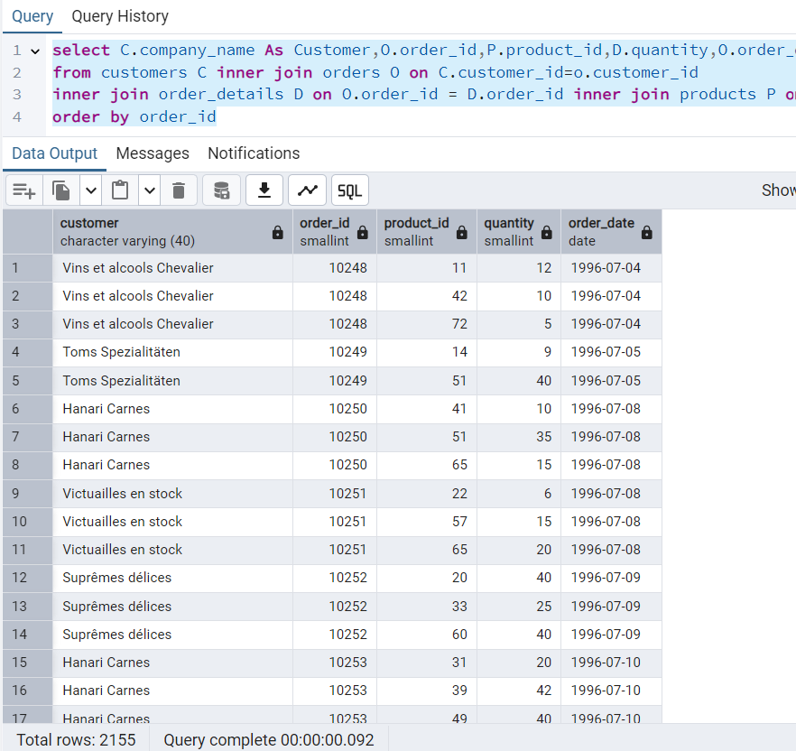

2. select O.order_id,C.company_name as customer, E.first_name || ' ' || E.last_name as employeename, S.company_name, P.product_name, D.quantity, O.order_date

from orders O

left join customers C ON O.customer_id = C.customer_id

left join employees E ON O.employee_id = E.employee_id

left join shippers S ON O.ship_via = S.shipper_id

left join order_details D ON O.order_id = D.order_id

left join products P ON D.product_id = P.product_id;

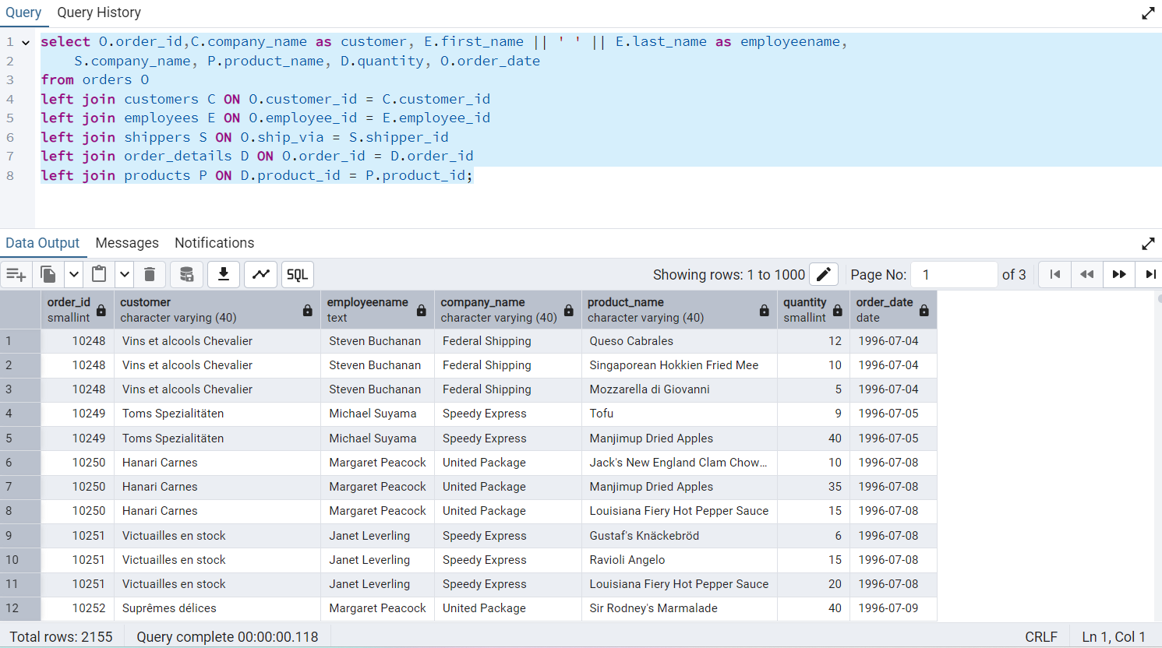

3. select O.order_id,P.product_id,O.quantity,P.product_name

from order_details O right join products P on P.product_id=O.product_id

order by O.order_id

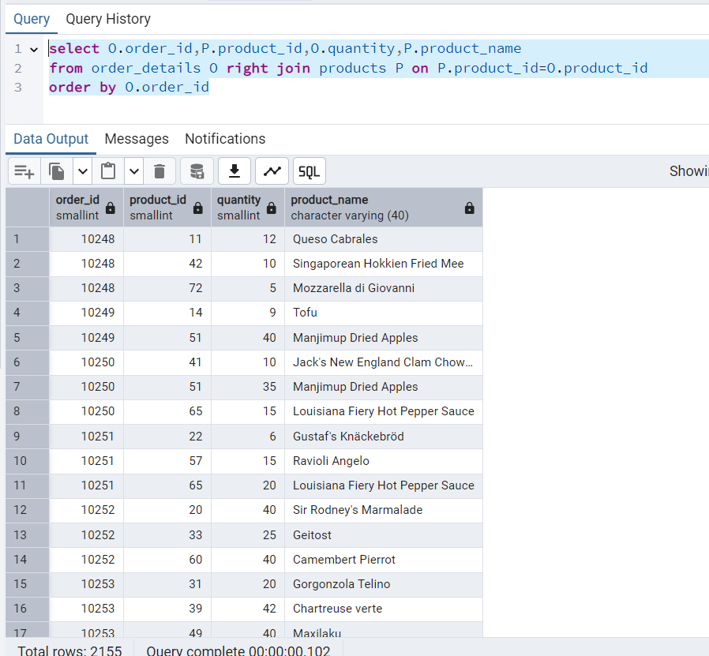

4. select *

from categories C full outer join products P on P.category_id=C.category_id

order by P.category_id

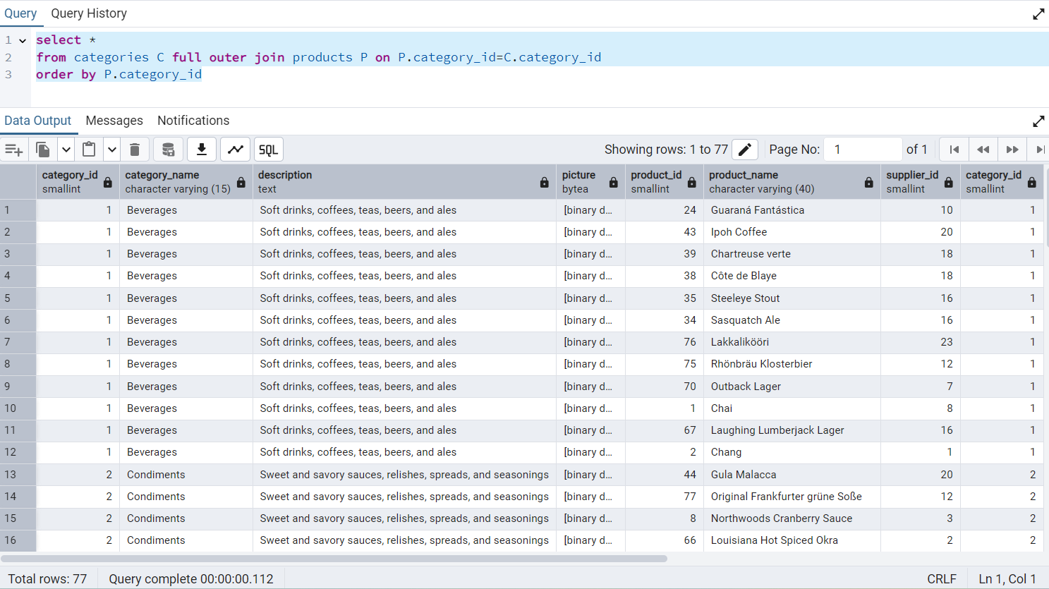

5. select * from categories C cross join products P

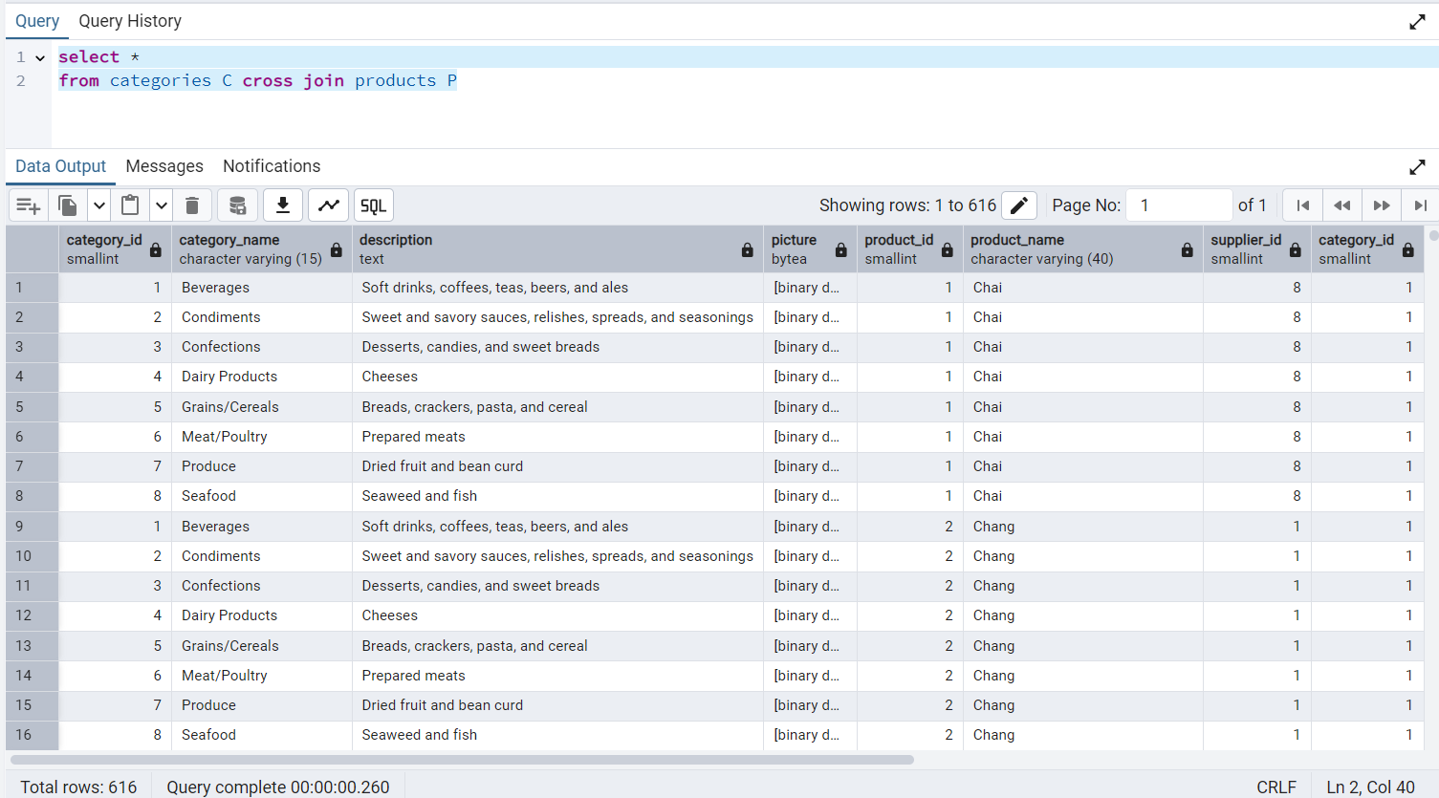

6. select E.employee_id, E.first_name || ' ' ||E.last_name as employeename,

M.first_name || ' ' ||M.last_name as managername

from employees E Left join employees M on E.reports_to = M.employee_id

order by E.employee_id

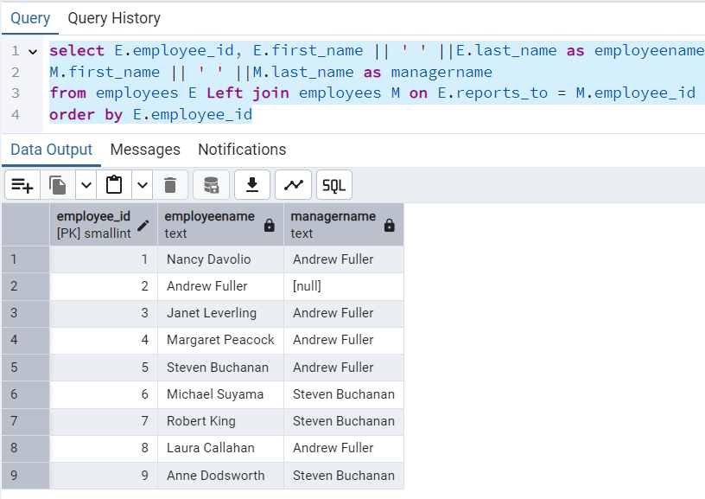

7. select * from categories C cross join products P

